

**Housing Price Prediction**

Submitted By

Jessica Ghimeliya

**ACKNOWLEDGMENT**

I would like to express my deep sense of gratitude to my SME (Subject Matter Expert) Miss. Sapna Verma as well as Flip Robo Technologies who gave me the golden opportunity to do this data analysis project on Housing: Price Prediction, which also helped me in doing lots of research and I came to know about so many new things.

I am very much thankful to Dr. Deepika, Trainer (DataTrained), for her valuable guidance, keen interest, and encouragement at various stages of my training period which eventually helped me a lot in doing this project.

I have utilized a few external resources that helped me to complete the project which is listed down:

* Real Estate Value Prediction Using Linear Regression - Nehal N Ghosalkar, Sudhir N Dhage
* Affordable Housing in the United States - By Gordon Davis, Jaime Bordenave, Roger Williams, Richard A. Hanson, and Richard Shields - June 12, 2006
* Housing Affordability Literature Review and Affordable Housing Program Audit – Elena Sliogeris, Louise Crabtree, Peter Phibbs and Kate Johnston
* <https://github.com/>
* <https://www.kaggle.com/>
* <https://towardsdatascience.com/>
* <https://www.analyticsvidhya.com/>

**INTRODUCTION**

**Business Problem Framing:**

Houses are one of the necessary needs of every person around the globe and therefore housing and real estate market is one of the markets which is one of the major contributors to the world’s economy. It is a very large market and various companies are working in the domain. Data science comes as a very important tool to solve problems in the domain to help the companies increase their overall revenue, profits, improve their marketing strategies, and focus on changing trends in house sales and purchases. Predictive modeling, Market mix modeling, recommendation systems are some of the machine learning techniques used for achieving the business goals for housing companies. Our problem is related to one such housing company.

A US-based housing company named Surprise Housing has decided to enter the Australian market. The company uses data analytics to purchase houses at a price below their actual values and flip them at a higher price. For the same purpose, the company has collected a data set from the sale of houses in Australia. The data is provided in the CSV file below.

The company is looking at prospective properties to buy houses to enter the market. It is required to build a model using Machine Learning to predict the actual value of the prospective properties and decide whether to invest in them or not. So we are building a model that helps to determine which variables are important to predict the price of variables & also how do these variables describe the price of the house.

This model will help to determine the price of houses with the available independent variables. This model will then be used by the management to understand how exactly the prices vary with the variables. They can accordingly manipulate the strategy of the firm and concentrate on areas that will yield high returns. Further, the model will be a good way for the management to understand the pricing dynamics of a new market.

**Conceptual Background of the Domain Problem:**

As we are working on the Housing project dataset we can easily understand that the data belongs to the Housing and Real Estate which will eventually involve several Financial, Costing, Are & Neighborhood, Statistical, and Technical terms in the dataset. This data belongs to A US-based housing company named Surprise Housing as they have decided to enter the Australian market. The company uses data analytics to purchase houses at a price below their actual values and flip them at a higher price. So here we need to understand several words related to the Core Domain.

The domain-related concepts which are useful for a better understanding of the project are.

Some relevant details of individual columns are,

1. MSSubClass: Identifies the type of dwelling involved in the sale.

20 1-STORY 1946 & NEWER ALL STYLES  
30 1-STORY 1945 & OLDER  
40 1-STORY W/FINISHED ATTIC ALL AGES  
45 1-1/2 STORY - UNFINISHED ALL AGES  
50 1-1/2 STORY FINISHED ALL AGES  
60 2-STORY 1946 & NEWER  
70 2-STORY 1945 & OLDER  
75 2-1/2 STORY ALL AGES  
80 SPLIT OR MULTI-LEVEL  
85 SPLIT FOYER  
90 DUPLEX - ALL STYLES AND AGES  
120 1-STORY PUD (Planned Unit Development) - 1946 & NEWER  
150 1-1/2 STORY PUD - ALL AGES  
160 2-STORY PUD - 1946 & NEWER  
180 PUD - MULTILEVEL - INCL SPLIT LEV/FOYER  
190 2 FAMILY CONVERSION - ALL STYLES AND AGES

2. MSZoning: Identifies the general zoning classification of the sale.

A Agriculture  
C Commercial  
FV Floating Village Residential  
I Industrial  
RH Residential High Density  
RL Residential Low Density  
RP Residential Low Density Park  
RM Residential Medium Density

3. LotFrontage: Linear feet of street connected to property

4. LotArea: Lot size in square feet

5. Street: Type of road access to property

Grvl Gravel  
Pave Paved

6. Alley: Type of alley access to property

Grvl Gravel  
Pave Paved  
NA No alley access

7. LotShape: General shape of property

Reg Regular  
IR1 Slightly irregular  
IR2 Moderately Irregular  
IR3 Irregular

8. LandContour: Flatness of the property

Lvl Near Flat/Level  
Bnk Banked - Quick and significant rise from street grade to building  
HLS Hillside - Significant slope from side to side  
Low Depression

9. Utilities: Type of utilities available

AllPub All public Utilities (E,G,W,& S)  
NoSewr Electricity, Gas, and Water (Septic Tank)  
NoSeWa Electricity and Gas Only  
ELO Electricity only

10. LotConfig: Lot configuration

Inside Inside lot  
Corner Corner lot  
CulDSac Cul-de-sac  
FR2 Frontage on 2 sides of property  
FR3 Frontage on 3 sides of property

11. LandSlope: Slope of property

Gtl Gentle slope  
Mod Moderate Slope  
Sev Severe Slope

12. Neighborhood: Physical locations within Ames city limits

Blmngtn Bloomington Heights  
Blueste Bluestem  
BrDale Briardale  
BrkSide Brookside  
ClearCr Clear Creek  
CollgCr College Creek  
Crawfor Crawford  
Edwards Edwards  
Gilbert Gilbert  
IDOTRR Iowa DOT and Rail Road  
MeadowV Meadow Village  
Mitchel Mitchell  
Names North Ames  
NoRidge Northridge  
NPkVill Northpark Villa  
NridgHt Northridge Heights  
NWAmes Northwest Ames  
OldTown Old Town  
SWISU South & West of Iowa State University  
Sawyer Sawyer  
SawyerW Sawyer West  
Somerst Somerset  
StoneBr Stone Brook  
Timber Timberland  
Veenker Veenker

13. Condition1: Proximity to various conditions

Artery Adjacent to arterial street  
Feedr Adjacent to feeder street  
Norm Normal  
RRNn Within 200' of North-South Railroad  
RRAn Adjacent to North-South Railroad  
PosN Near positive off-site feature--park, greenbelt, etc.  
PosA Adjacent to postive off-site feature  
RRNe Within 200' of East-West Railroad  
RRAe Adjacent to East-West Railroad

14. Condition2: Proximity to various conditions (if more than one is present)

Artery Adjacent to arterial street  
Feedr Adjacent to feeder street  
Norm Normal  
RRNn Within 200' of North-South Railroad  
RRAn Adjacent to North-South Railroad  
PosN Near positive off-site feature--park, greenbelt, etc.  
PosA Adjacent to postive off-site feature  
RRNe Within 200' of East-West Railroad  
RRAe Adjacent to East-West Railroad

15. BldgType: Type of dwelling

1Fam Single-family Detached  
2FmCon Two-family Conversion; originally built as one-family dwelling  
Duplx Duplex  
TwnhsE Townhouse End Unit  
TwnhsI Townhouse Inside Unit

16. HouseStyle: Style of dwelling

1Story One story  
1.5Fin One and one-half story: 2nd level finished  
1.5Unf One and one-half story: 2nd level unfinished  
2Story Two story  
2.5Fin Two and one-half story: 2nd level finished  
2.5Unf Two and one-half story: 2nd level unfinished  
SFoyer Split Foyer  
SLvl Split Level

17. OverallQual: Rates the overall material and finish of the house

10 Very Excellent  
9 Excellent  
8 Very Good  
7 Good  
6 Above Average  
5 Average  
4 Below Average  
3 Fair  
2 Poor  
1 Very Poor

18. OverallCond: Rates the overall condition of the house

10 Very Excellent  
9 Excellent  
8 Very Good  
7 Good  
6 Above Average  
5 Average  
4 Below Average  
3 Fair  
2 Poor  
1 Very Poor

19. YearBuilt: Original construction date

20. YearRemodAdd: Remodel date (same as construction date if no remodeling or additions)

21. RoofStyle: Type of roof

Flat Flat  
Gable Gable  
Gambrel Gabrel (Barn)  
Hip Hip  
Mansard Mansard  
Shed Shed

22. RoofMatl: Roof material

ClyTile Clay or Tile  
CompShg Standard (Composite) Shingle  
Membran Membrane  
Metal Metal  
Roll Roll  
Tar&Grv Gravel & Tar  
WdShake Wood Shakes  
WdShngl Wood Shingles

23. Exterior1st: Exterior covering on house

AsbShng Asbestos Shingles  
AsphShn Asphalt Shingles  
BrkComm Brick Common  
BrkFace Brick Face  
CBlock Cinder Block  
CemntBd Cement Board  
HdBoard Hard Board  
ImStucc Imitation Stucco  
MetalSd Metal Siding  
Other Other  
Plywood Plywood  
PreCast PreCast  
Stone Stone  
Stucco Stucco  
VinylSd Vinyl Siding  
Wd Sdng Wood Siding  
WdShing Wood Shingles

24. Exterior2nd: Exterior covering on house (if more than one material)

AsbShng Asbestos Shingles  
AsphShn Asphalt Shingles  
BrkComm Brick Common  
BrkFace Brick Face  
CBlock Cinder Block  
CemntBd Cement Board  
HdBoard Hard Board  
ImStucc Imitation Stucco  
MetalSd Metal Siding  
Other Other  
Plywood Plywood  
PreCast PreCast  
Stone Stone  
Stucco Stucco  
VinylSd Vinyl Siding  
Wd Sdng Wood Siding  
WdShing Wood Shingles

25. MasVnrType: Masonry veneer type

BrkCmn Brick Common  
BrkFace Brick Face  
CBlock Cinder Block  
None None  
Stone Stone

26. MasVnrArea: Masonry veneer area in square feet

27. ExterQual: Evaluates the quality of the material on the exterior

Ex Excellent  
Gd Good  
TA Average/Typical  
Fa Fair  
Po Poor

28. ExterCond: Evaluates the present condition of the material on the exterior

Ex Excellent  
Gd Good  
TA Average/Typical  
Fa Fair  
Po Poor

29. Foundation: Type of foundation

BrkTil Brick & Tile  
CBlock Cinder Block  
PConc Poured Contrete  
Slab Slab  
Stone Stone  
Wood Wood

30. BsmtQual: Evaluates the height of the basement

Ex Excellent (100+ inches)  
Gd Good (90-99 inches)  
TA Typical (80-89 inches)  
Fa Fair (70-79 inches)  
Po Poor (<70 inches  
NA No Basement

31. BsmtCond: Evaluates the general condition of the basement

Ex Excellent  
Gd Good  
TA Typical - slight dampness allowed  
Fa Fair - dampness or some cracking or settling  
Po Poor - Severe cracking, settling, or wetness  
NA No Basement

32. BsmtExposure: Refers to walkout or garden level walls

Gd Good Exposure  
Av Average Exposure (split levels or foyers typically score average or above)  
Mn Mimimum Exposure  
No No Exposure  
NA No Basement

33. BsmtFinType1: Rating of basement finished area

GLQ Good Living Quarters  
ALQ Average Living Quarters  
BLQ Below Average Living Quarters  
Rec Average Rec Room  
LwQ Low Quality  
Unf Unfinshed  
NA No Basement

34. BsmtFinSF1: Type 1 finished square feet

35. BsmtFinType2: Rating of basement finished area (if multiple types)

GLQ Good Living Quarters  
ALQ Average Living Quarters  
BLQ Below Average Living Quarters  
Rec Average Rec Room  
LwQ Low Quality  
Unf Unfinshed  
NA No Basement

36. BsmtFinSF2: Type 2 finished square feet

37. BsmtUnfSF: Unfinished square feet of basement area

38. TotalBsmtSF: Total square feet of basement area

39. Heating: Type of heating

Floor Floor Furnace  
GasA Gas forced warm air furnace  
GasW Gas hot water or steam heat  
Grav Gravity furnace  
OthW Hot water or steam heat other than gas  
Wall Wall furnace

40. HeatingQC: Heating quality and condition

Ex Excellent  
Gd Good  
TA Average/Typical  
Fa Fair  
Po Poor

41. CentralAir: Central air conditioning

N No  
Y Yes

42. Electrical: Electrical system

SBrkr Standard Circuit Breakers & Romex  
FuseA Fuse Box over 60 AMP and all Romex wiring (Average)  
FuseF 60 AMP Fuse Box and mostly Romex wiring (Fair)  
FuseP 60 AMP Fuse Box and mostly knob & tube wiring (poor)  
Mix Mixed

43. 1stFlrSF: First Floor square feet

44. 2ndFlrSF: Second floor square feet

45. LowQualFinSF: Low quality finished square feet (all floors)

46. GrLivArea: Above grade (ground) living area square feet

47. BsmtFullBath: Basement full bathrooms

48. BsmtHalfBath: Basement half bathrooms

49. FullBath: Full bathrooms above grade

50. HalfBath: Half baths above grade

51. Bedroom: Bedrooms above grade (does NOT include basement bedrooms)

52. Kitchen: Kitchens above grade

53. KitchenQual: Kitchen quality

Ex Excellent  
Gd Good  
TA Typical/Average  
Fa Fair  
Po Poor

54. TotRmsAbvGrd: Total rooms above grade (does not include bathrooms)

55. Functional: Home functionality (Assume typical unless deductions are warranted)

Typ Typical Functionality  
Min1 Minor Deductions 1  
Min2 Minor Deductions 2  
Mod Moderate Deductions  
Maj1 Major Deductions 1  
Maj2 Major Deductions 2  
Sev Severely Damaged  
Sal Salvage only

56. Fireplaces: Number of fireplaces

57. FireplaceQu: Fireplace quality

Ex Excellent - Exceptional Masonry Fireplace  
Gd Good - Masonry Fireplace in main level  
TA Average - Prefabricated Fireplace in main living area or Masonry Fireplace in basement  
Fa Fair - Prefabricated Fireplace in basement  
Po Poor - Ben Franklin Stove  
NA No Fireplace

58. GarageType: Garage location

2Types More than one type of garage  
Attchd Attached to home  
Basment Basement Garage  
BuiltIn Built-In (Garage part of house - typically has room above garage)  
CarPort Car Port  
Detchd Detached from home  
NA No Garage

59. GarageYrBlt: Year garage was built

60. GarageFinish: Interior finish of the garage

Fin Finished  
RFn Rough Finished  
Unf Unfinished  
NA No Garage

61. GarageCars: Size of garage in car capacity

62. GarageArea: Size of garage in square feet

63. GarageQual: Garage quality

Ex Excellent  
Gd Good  
TA Typical/Average  
Fa Fair  
Po Poor  
NA No Garage

64. GarageCond: Garage condition

Ex Excellent  
Gd Good  
TA Typical/Average  
Fa Fair  
Po Poor  
NA No Garage

65. PavedDrive: Paved driveway

Y Paved  
P Partial Pavement  
N Dirt/Gravel

66. WoodDeckSF: Wood deck area in square feet

67. OpenPorchSF: Open porch area in square feet

68. EnclosedPorch: Enclosed porch area in square feet

69. 3SsnPorch: Three season porch area in square feet

70. ScreenPorch: Screen porch area in square feet

71. PoolArea: Pool area in square feet

72. PoolQC: Pool quality

Ex Excellent  
Gd Good  
TA Average/Typical  
Fa Fair  
NA No Pool

73. Fence: Fence quality

GdPrv Good Privacy  
MnPrv Minimum Privacy  
GdWo Good Wood  
MnWw Minimum Wood/Wire  
NA No Fence

74. MiscFeature: Miscellaneous feature not covered in other categories

Elev Elevator  
Gar2 2nd Garage (if not described in garage section)  
Othr Other  
Shed Shed (over 100 SF)  
TenC Tennis Court  
NA None

75. MiscVal: $Value of miscellaneous feature

76. MoSold: Month Sold (MM)

77. YrSold: Year Sold (YYYY)

78. SaleType: Type of sale

WD Warranty Deed – Conventional  
CWD Warranty Deed – Cash  
VWD Warranty Deed - VA Loan  
New Home just constructed and sold  
COD Court Officer Deed/Estate  
Con Contract 15% Down payment regular terms  
ConLw Contract Low Down payment and low interest  
ConLI Contract Low Interest  
ConLD Contract Low Down  
Oth Other

79. SaleCondition: Condition of sale

Normal Normal Sale  
Abnorml Abnormal Sale - trade, foreclosure, short sale  
AdjLand Adjoining Land Purchase  
Alloca Allocation - two linked properties with separate deeds, typically condo with a garage unit  
Family Sale between family members  
Partial Home was not completed when last assessed (associated with New Homes)

**Review of Literature:**

In this section, we are discussing the reported work carried out in various fields of Housing projects & Real Estate sectors.

**Nehal N Ghosalkar et. Al.,** describes that the real estate market is a standout amongst the most focused regarding pricing and keeps fluctuating. It is one of the prime fields to apply the ideas of machine learning on how to enhance and foresee the costs with high accuracy. Three factors influence the price of a house which include physical conditions, concepts, and location. The current framework includes estimating the price of houses without any expectations of market prices and cost increments. The objective of the paper is the prediction of residential prices for the customers considering their financial plans and needs. By breaking down past market patterns and value ranges, and coming advancements future costs will be anticipated. This examination means to predict house prices in the city with Linear Regression. It will help clients to put resources into a bequest without moving toward a broker.

**George Earl et. Al.** describe that markets are the central institutions of economies, allowing people to buy and sell goods and services in a manner that potentially makes everyone better off. However, markets can only be formed under certain conditions, and when these conditions are absent, markets may struggle to exist or the conditions may lead to market failures. This is the basic underlying principle of missing or incomplete markets; that is, failure to produce some goods and services despite being needed or wanted. It is well known that microeconomic equilibrium occurs when the demand for goods is equal to the supply. A missing market, therefore, is a sign that the market is out of equilibrium; a situation where markets do not exist or where the equilibrium price is not related to either marginal social benefits or marginal social costs. For decades, the market has been failing to meet the housing needs of its lowest-income residents, and the situation is getting steadily worse. Many people on low incomes cannot afford to buy their own homes, and housing rents have also become increasingly unaffordable in recent years. Therefore, by definition, sustainable housing means that everyone should have the opportunity to live in a decent home at a price they can afford, in a place in which they want to live and work.

**Elena Sliogeris et. Al.** describe that the incidence of the problem has spread from very low-income through low-income into moderate-income households. There is now a consistent call for housing schemes to retain ‘key workers’ and ‘the working poor’ in established areas to ensure access to employment, education, public transport, and other facilities and amenities. Land com has a strategic position within this landscape and there exists a range of current and potential mechanisms land com might utilize to create and maintain a pool of affordable houses. Numerous interrelated factors have driven the loss of affordability, including an increased willingness and capacity to pay for housing due to increased incomes and more accessible lines of credit. Concurrent increases in a population decrease in household size, and increases in house size have further compounded the problem. The role of supply-side

impediments to housing development that contributes to a loss of affordability is strongly contested. The planning processes may have a role to play in addressing affordability concerns. However, the house prices are largely countered by recent market conditions in city areas that have continued to increase in price while house prices in outer areas have stagnated or decreased in value. The landscape of affordability is influenced to a large extent by access to jobs, public transport, and other social amenities. This highlights the need for future housing provision to address employment, transport, and other infrastructure as well as the volume of housing supply.

**Motivation for the Problem Undertaken**

The prime intention of performing this project is to build a Machine Learning model to predict house prices with the help of other supporting feature attributes. The sample data is provided by our client database. To improve the selection of customers, the client wants some predictions that could help them in further investment and improvement in the selection of customers. House Price Index (HPI) is commonly used to estimate the changes in housing prices. Since housing price is strongly correlated to other factors such as location, area, etc, it requires other information apart from HPI to predict individual housing prices.

There has been a considerably large number of papers adopting traditional machine learning approaches to predict housing prices accurately, but they rarely concern themselves with the performance of individual models and neglect the less popular yet complex models.

As a result, to explore various impacts of features on prediction methods, this paper will apply both traditional and advanced machine learning approaches to investigate the difference among several advanced models. This analysis will also comprehensively validate multiple techniques in model implementation on regression and provide an optimistic result for housing price prediction.

This model will be used by the management to understand how exactly the prices vary with the variables. They can accordingly manipulate the strategy of the firm and concentrate on areas that will yield high returns. Further, the model will be a good way for the management to understand the pricing dynamics of a new market.

**Analytical Problem Framing**

* Mathematical/ Analytical Modeling of the Problem:

The provided dataset is in CSV format. We will begin with loading the dataset and reading the dataset from the CSV file using the read_csv() function from the Pandas Python package. Next, we will perform Non-Graphical Exploratory Data Analysis (EDA) such as checking the data types and missing values using pandas info() function, Then, we will get statistical information about the numeric columns in our dataset using pandas.DataFrame.describe() method. We want to know the mean, the standard deviation, the minimum, the maximum, and the 50th percentile (the median) for each numeric column in the dataset. After that, we will move on to perform graphical EDA to get more insights from our dataset and how the feature attribute affects the target attribute.

Next, we will perform data pre-processing to treat the missing values, dropping columns not helpful for our model prediction, removing outliers if there is, removing skewness, etc. Further, we will build a full pipeline for our model prediction.

Since we have to predict house prices in this dataset therefore we will be building and training a few regression-based models to predict the price of the houses.

* Data Sources and their formats:

The dataset is being provided by Flip Robo and is in the format of CSV (Comma Separated Values). Let’s load it and start the analysis.

**Importing Libraries**

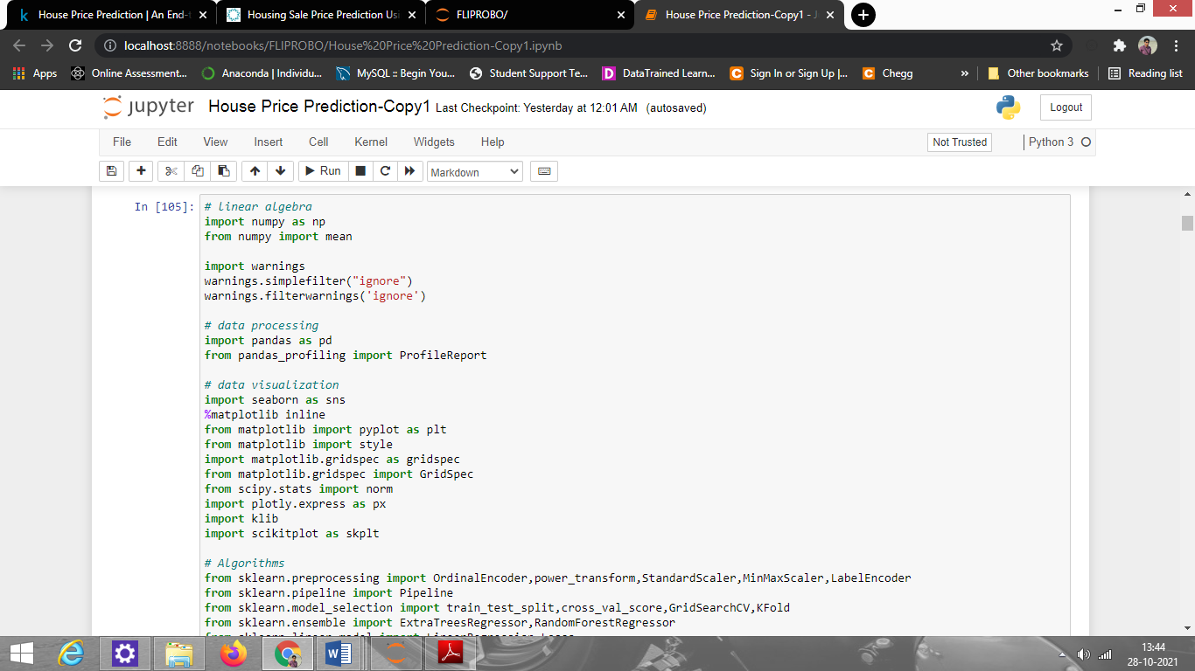

**Loading the dataset**

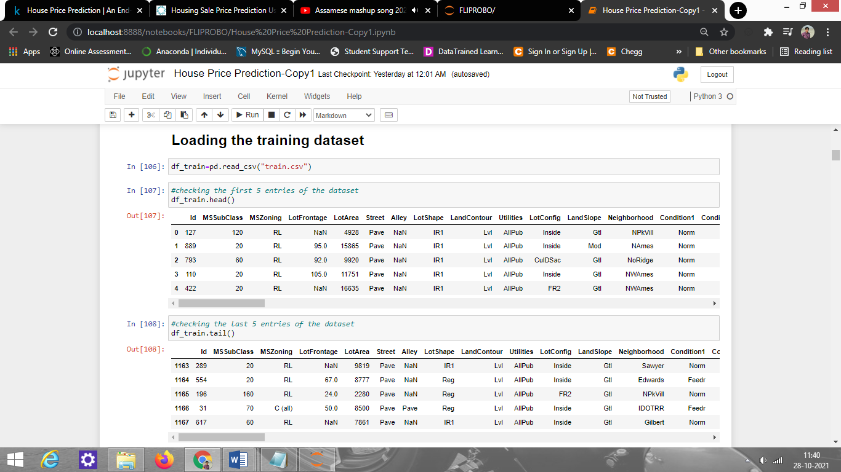

**The dimension of data is 1168 rows and 81 columns**.

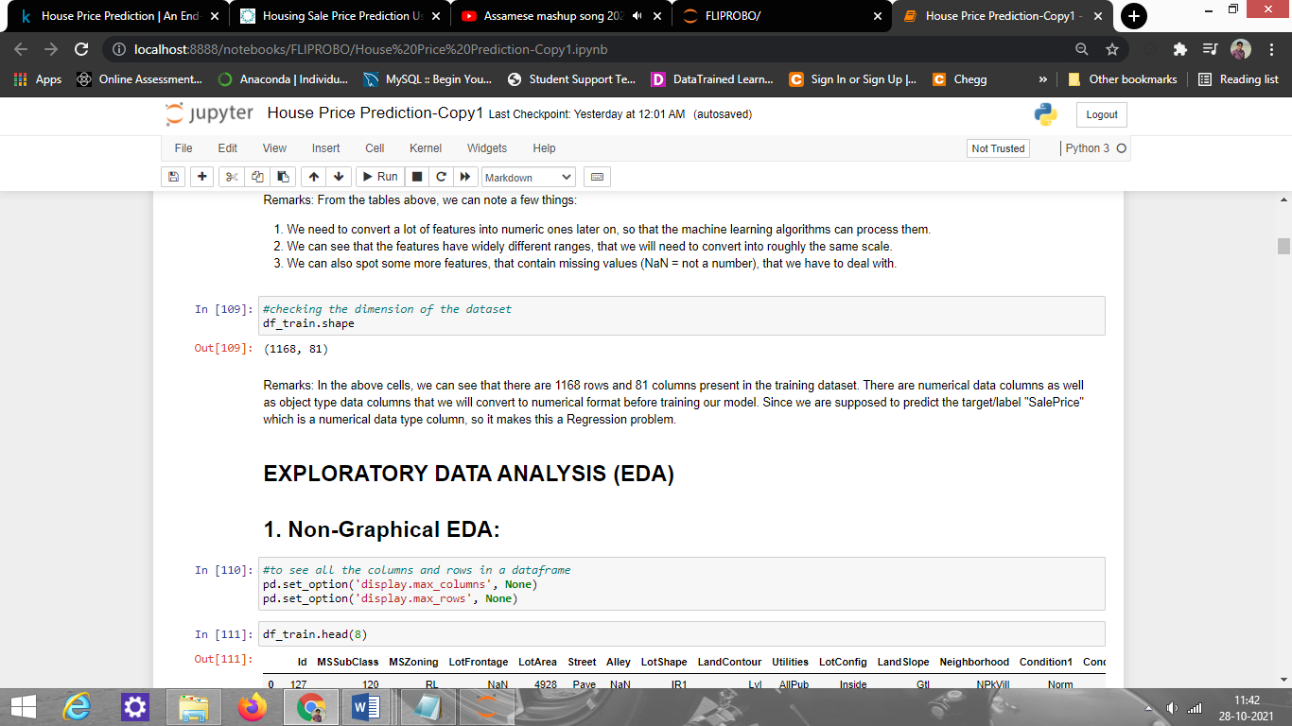

Two data sets are given. One is training data and one is testing data.

1) Train file will be used for training the model, i.e., the model will learn from this file. It contains all the independent variables and the target variable. Size of training set: 1168 records.

2) Test file contains all the independent variables, but not the target variable. We will apply the model to predict the target variable for the test data. Size of testing set: 292 records.

**The data type information:**

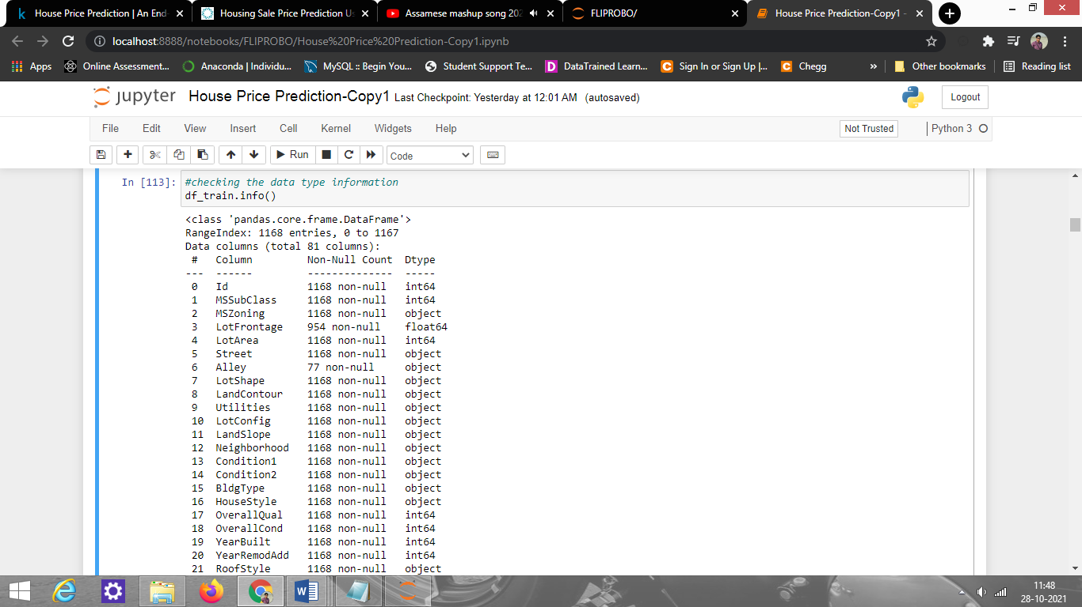

**Observations made from the data type information-**

* There are 38 numerical columns and 43 categorical columns
* Some columns should be an object such as mssubclass, overallqual, etc. but are in numerical format.

**Checking missing/null values present in the dataset**

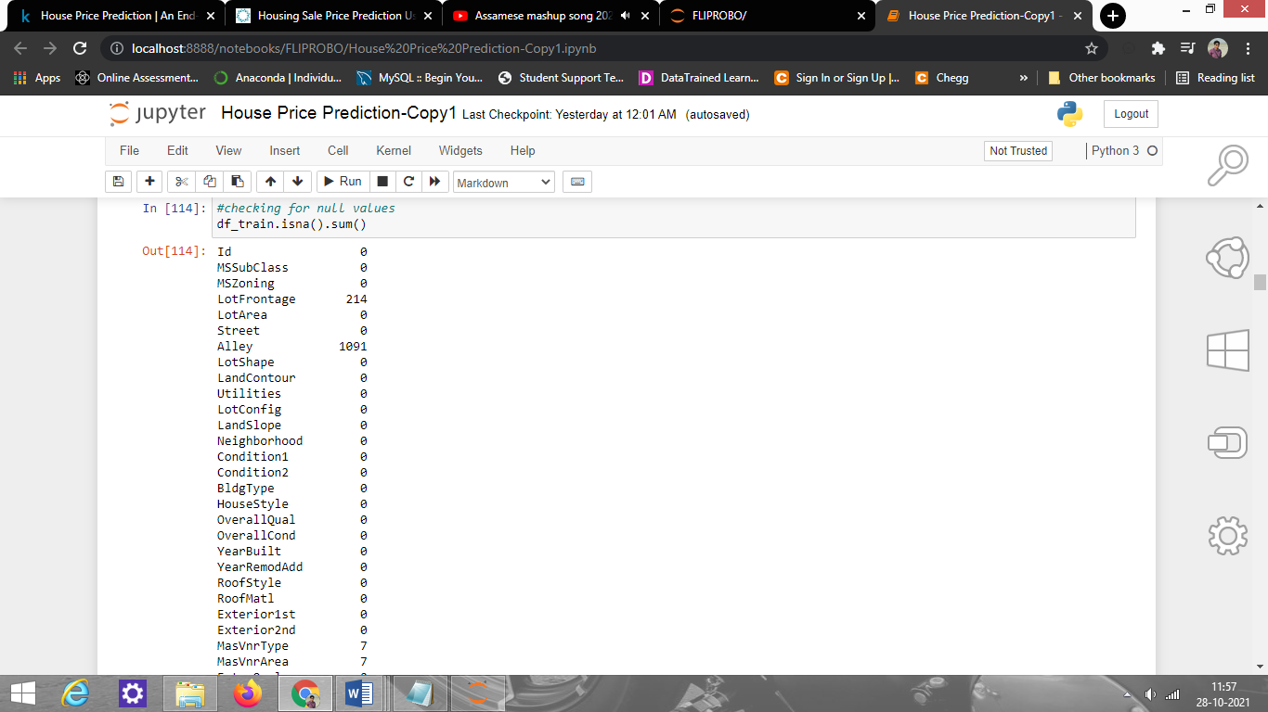

There are many missing values that we have to handle before model training. I am treating some columns that have numerous missing values by replacing them with None for categorical columns, and numerical columns, I am replacing them with 0 only when if they have a lot of missing values.

And for the columns having fewer missing values, I am replacing them with mode for categorical columns, and for numerical I am replacing them with mean.

**Statistical summary of the data:**

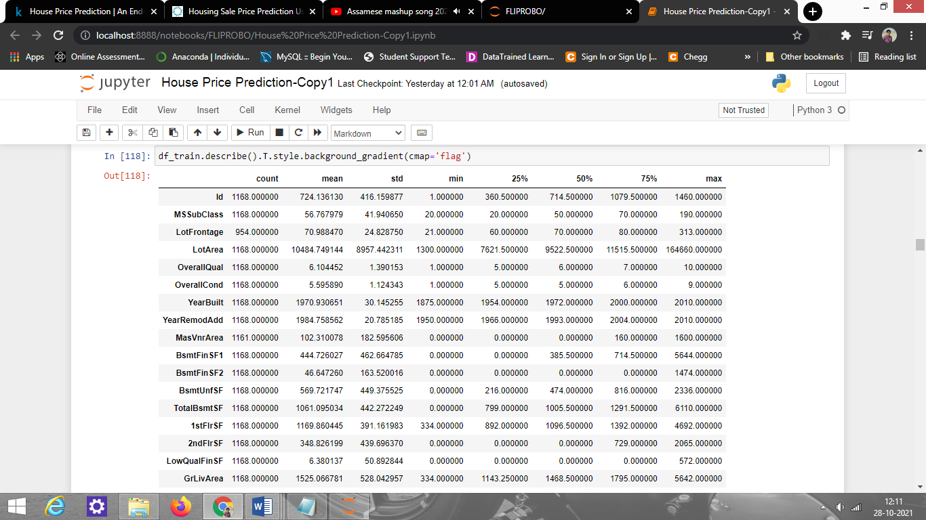

From this summary, we can see all the numeric value details and also see the spread of the data like the target "SalePrice" has a min value of 34900 and a max value of 755000. Also, the count is not the same for all the columns indicating that there are missing values present in the dataset.

* Data Pre-processing:

Data pre-processing in Machine Learning refers to the technique of preparing (cleaning and organizing) the raw data to make it suitable for building and training Machine Learning models. In other words, whenever the data is gathered from different sources it is collected in raw format which is not feasible for the analysis. Therefore, it is extremely important that we pre-process our data before feeding it into our model as the quality of data and the useful information that can be derived from it directly affects the ability of our model to learn. The steps that were performed are as follows-

* **Filling /Treating Missing values:** We have defined a function to treat the missing values present. I am treating some columns that have numerous missing values by replacing them with None for categorical columns, and numerical columns, I am replacing them with 0 only when if they have a lot of missing values. And for the columns having fewer missing values, I am replacing them with mode for categorical columns, and for numerical I am replacing them with mean.

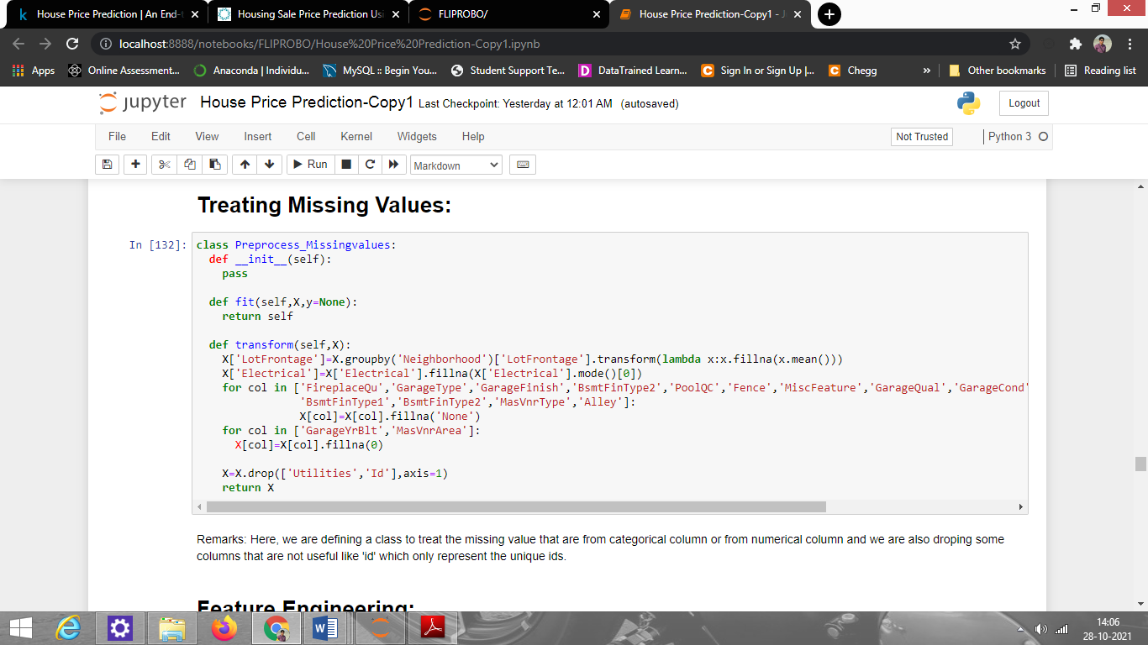

* **Feature Engineering:** we have defined a class to create more features so our machine learning models performs well. Feature engineering is one of the most important method in ML.

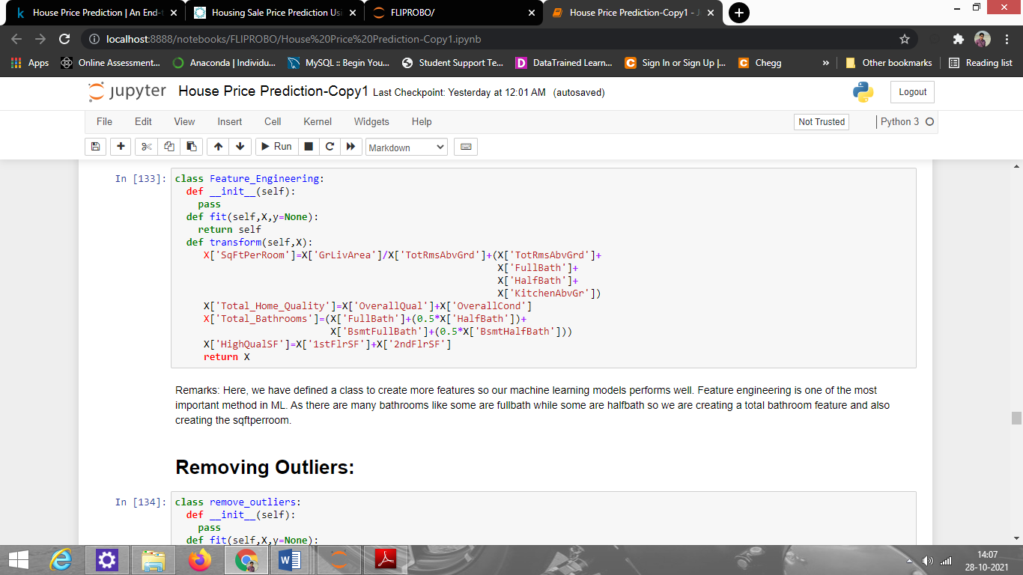

* **Feature Transformation**: We are using LabelEncode to encode the **categorical features**

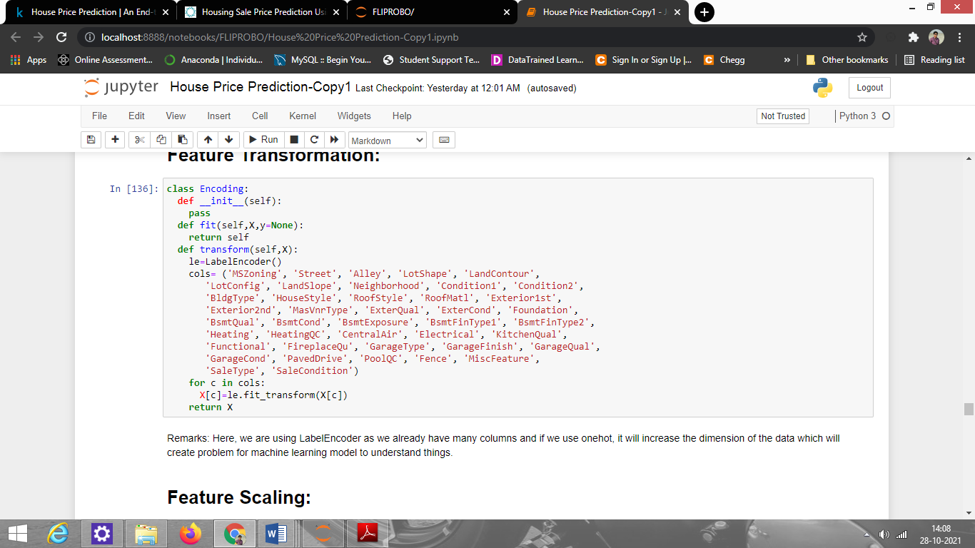

* **Handling Multi-collinearity**: With the help of heatmap & correlation bar graph we were able to understand the feature vs target relativity and insights on multi-collinearity amongst the feature columns.

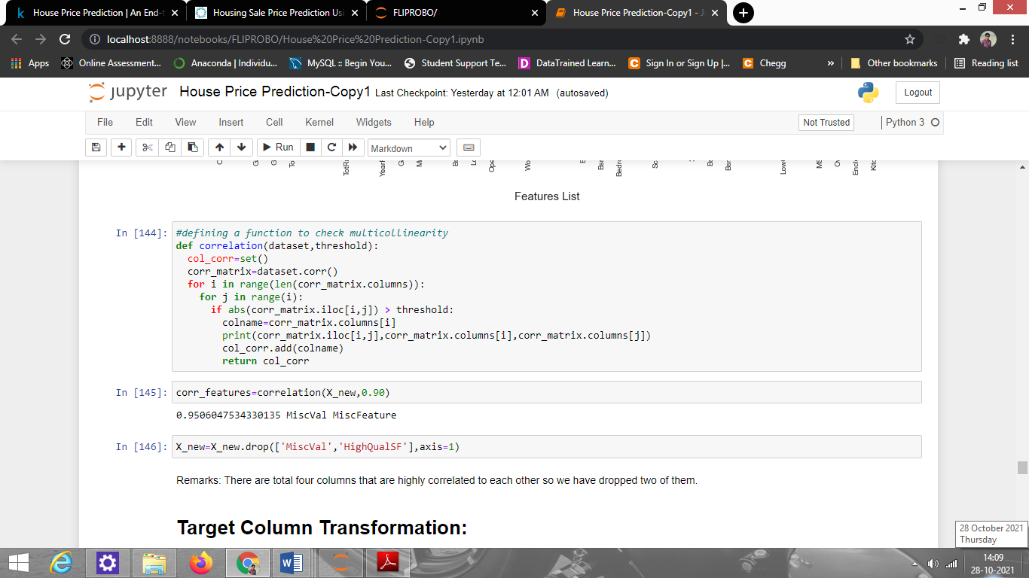

* **Removing Outliers:**  with the help of percentile method as we can replace the outliers with percentile value and don't lose any data.

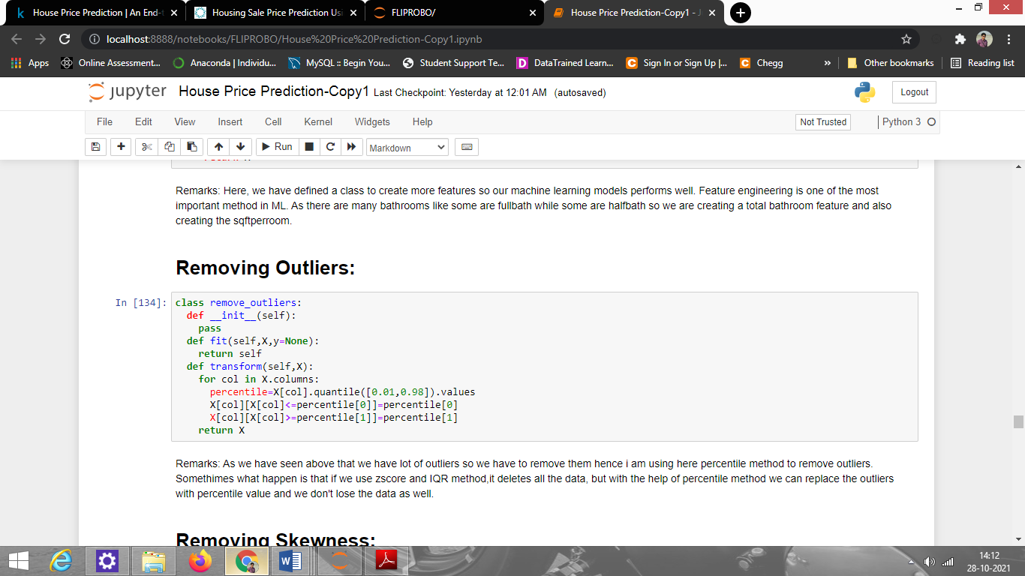

* **Removing Skewness** of continuous data (with threshold value -1 to +1) using power_transform function from sklearn.preprocessing.

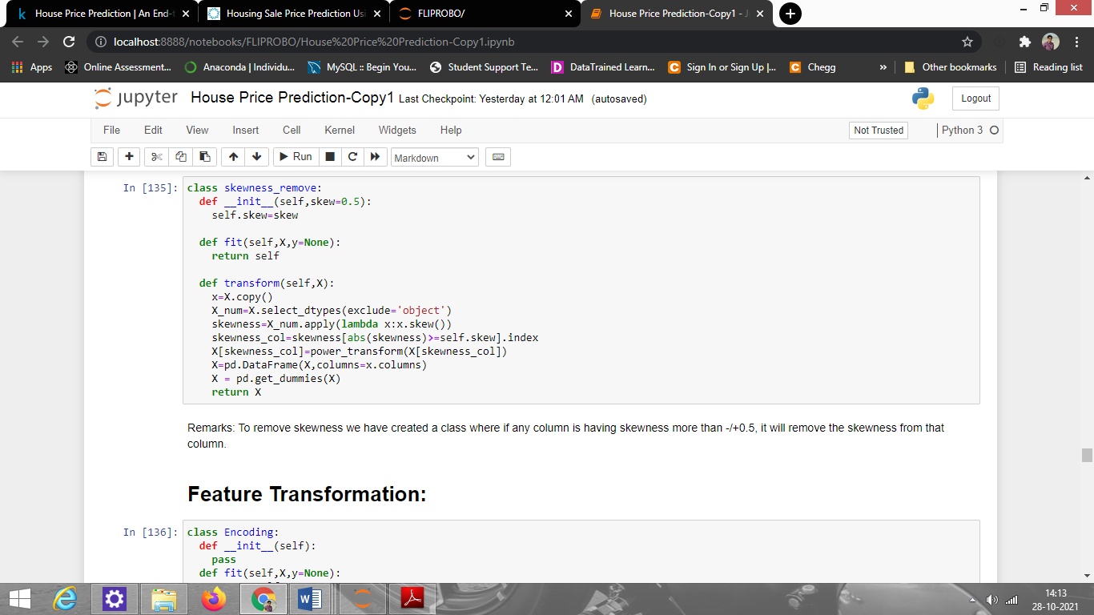

* **Feature Scaling:** we are using StandardScaler to scale all high values to same scale

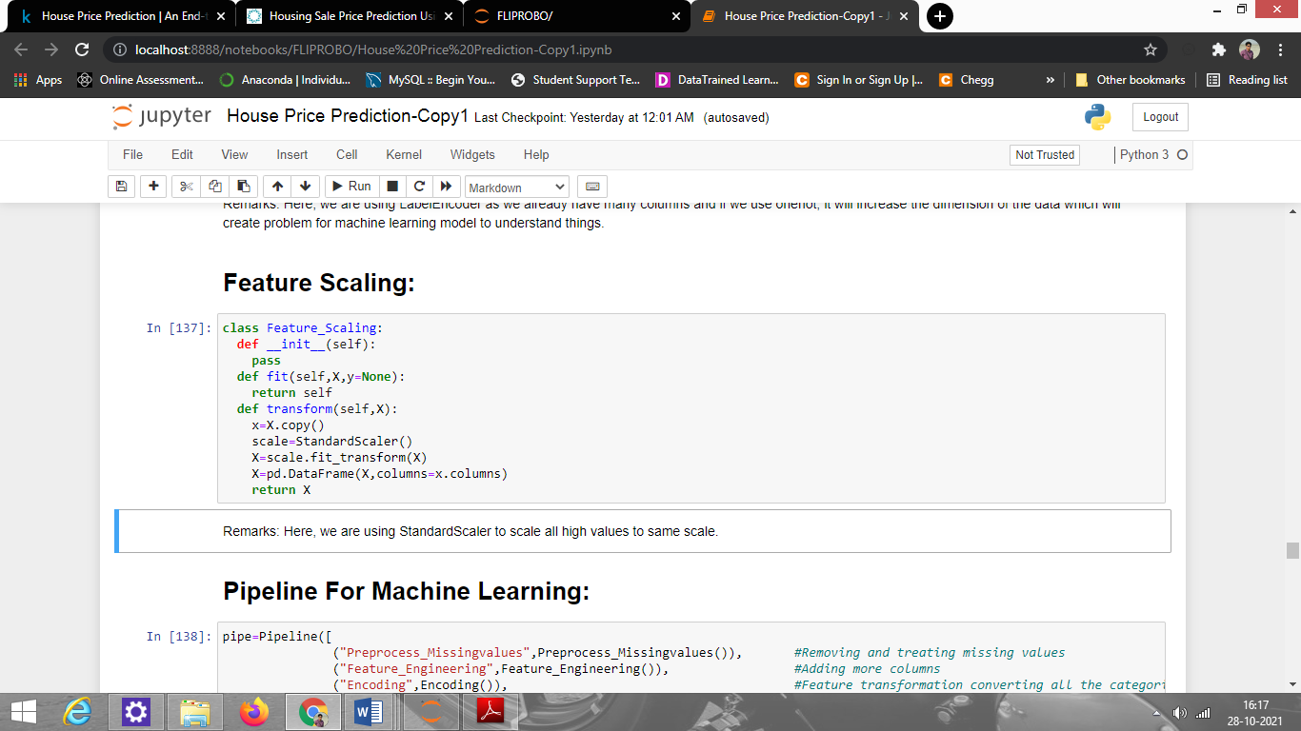

* Data Inputs- Logic- Output Relationships:

The given dataset has 78 input variables after pre-processing of the data that needs to be provided to the logic to get the output i.e. SalePrice. The below EDA describes the relationship behind the data input, its format, the logic in between, and the output. For EDA we have used different types of plots such as count plot, barplot, strip plot, boxplot, heatmap, etc.

**BarPlots:**

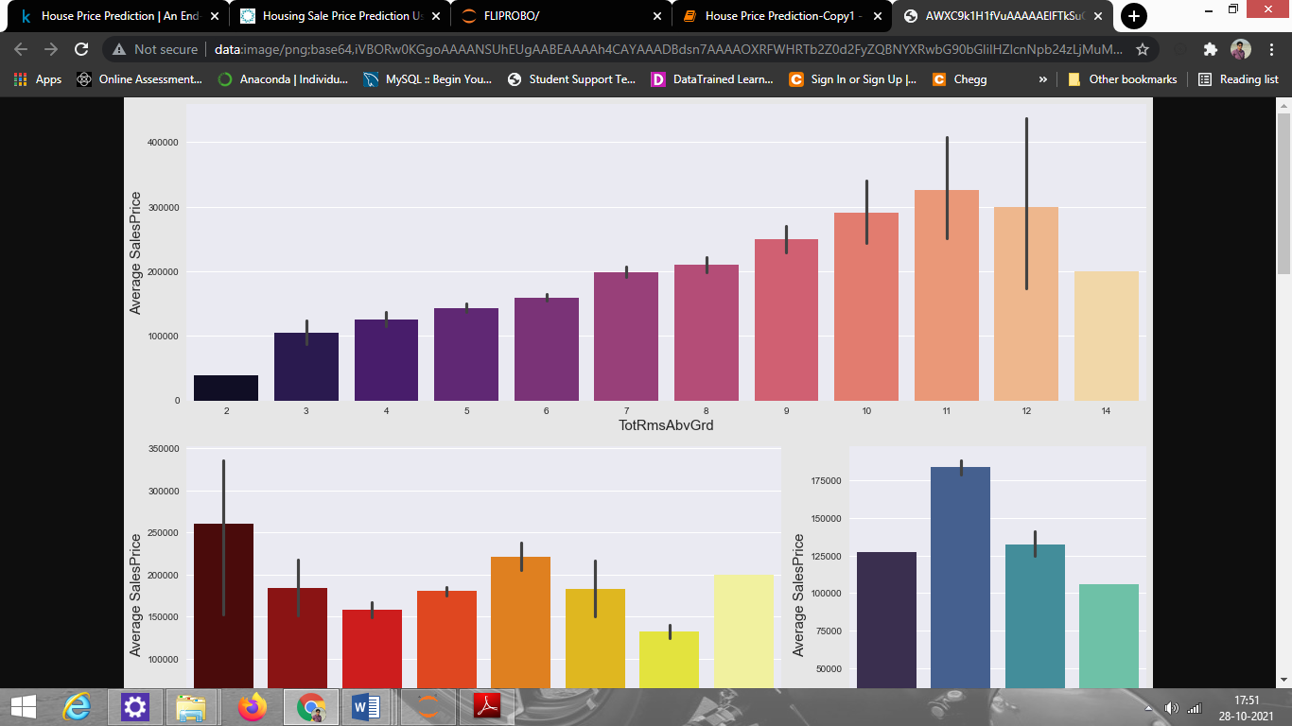

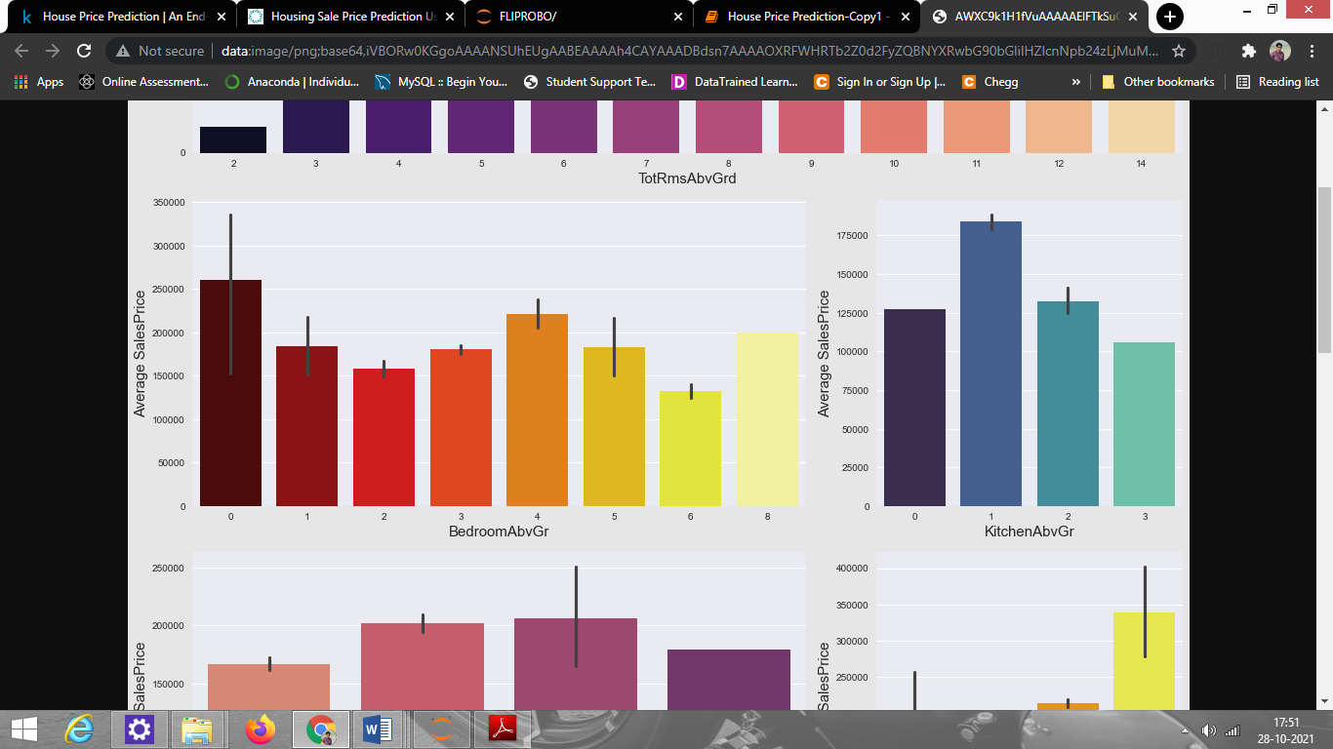

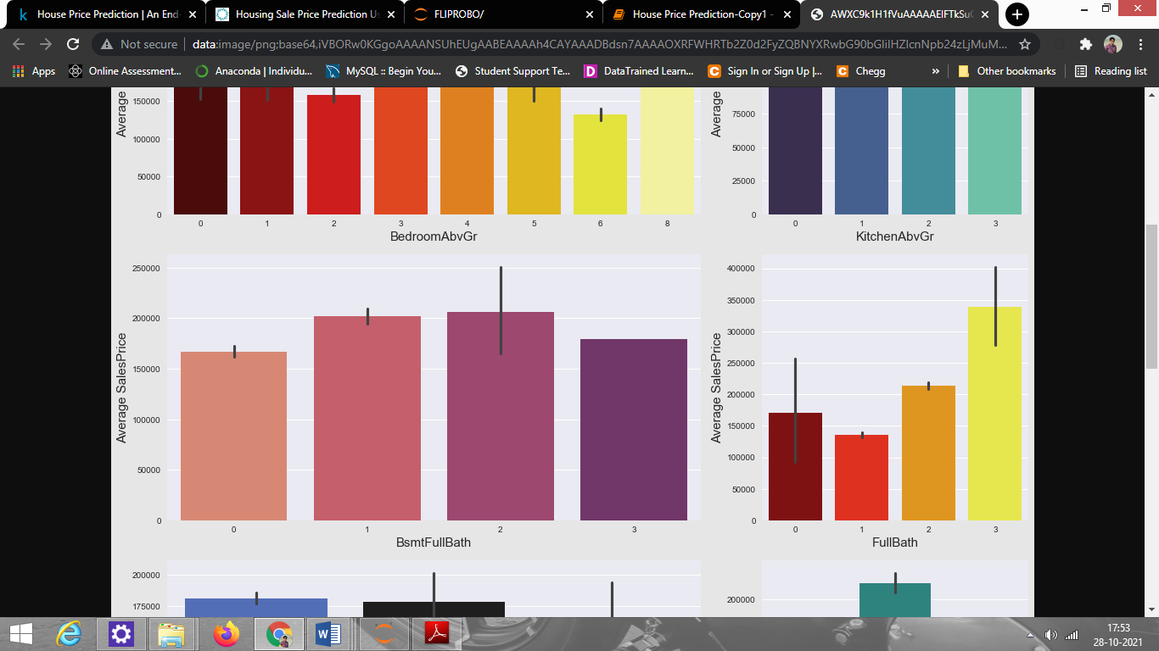

Observations:

1. From TotRmsAbvGrd vs SalePrice plot, we see that as total rooms Above Ground are increasing, the average price is also increasing until the 11th room and the price starts to decrease.
2. From the Bedroom Above Ground Vs Saleprice plot, we can see that for the 0, 4, 8 Bedroom number, the price is high and the price is very less for 6 and 2 bedroom numbers.
3. From the Kitchen above Ground Vs saleprice plot, we can see that as the no. of the kitchen is increasing, the price is decreasing indicating mostly people take one kitchen house only.
4. In Basement full bathroom & half bathrooms vs saleprice plot, we see that as the bathroom size increases, the price is also increasing.

**Boxplots**:

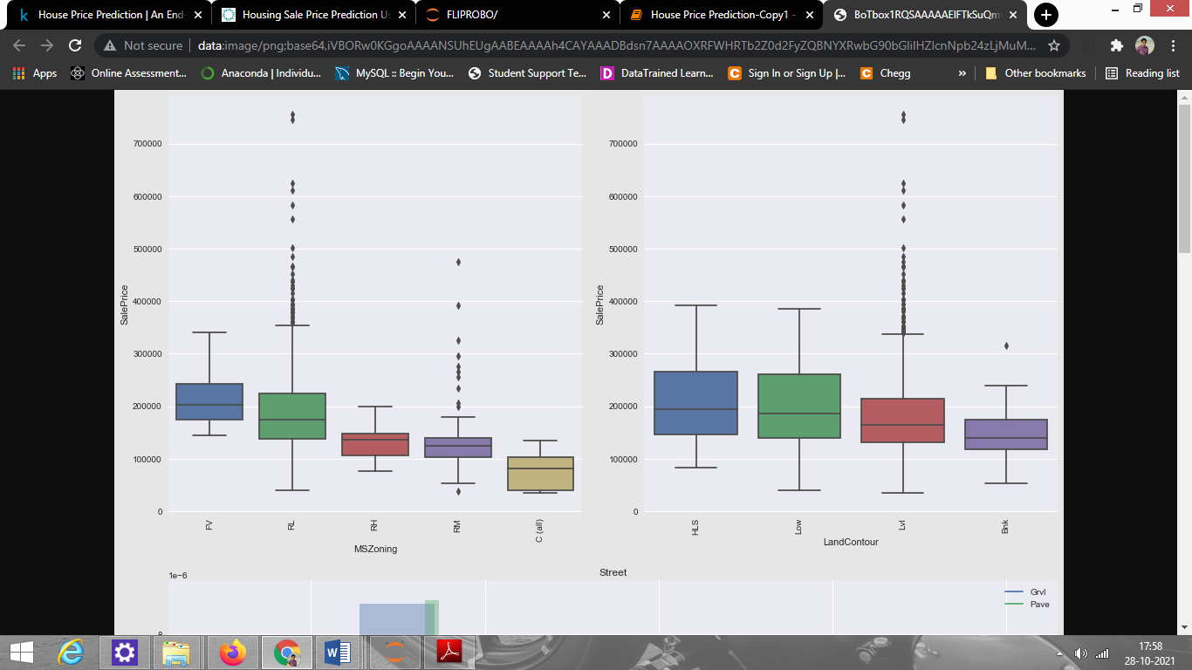

Observations:

1. From MSZoning vs Saleprice plot, we see that the Floating Village Residential zone (FV) is having a higher sale price of around 2 lakhs While Commercial Zones are having the lowest sale prices and we see a variation in sale prices in different zones which makes it an important feature for our prediction.
2. From LandCountour vs saleprice plot, we see that if the house has a significant slope on both sides (HLS) or has depression (Low), sale prices are more. For nearly flat/level and banked slopes, the Sale price is less.

**Distribution plot**:

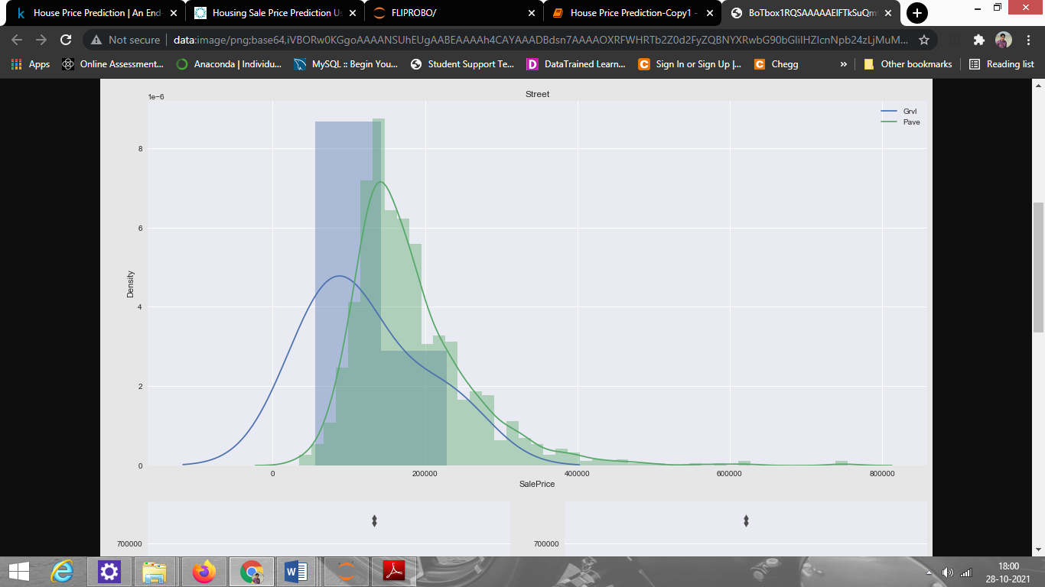\

Observation:  We see that For flat stones or bricks access streets, the Price is higher and the majority of houses with gravel streets have a price around 2 lakhs but as there is very little data for gravel street type this feature is not that important for prediction.

**Stripplot:**

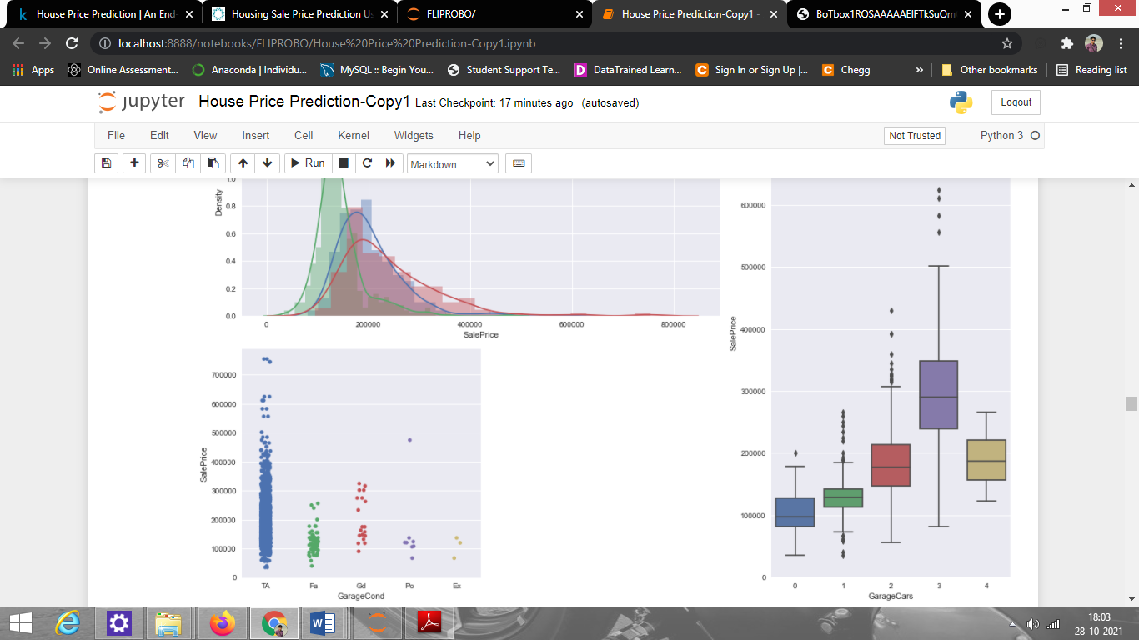

Observation: From Garagecond vs saleprice plot, we see that houses with typical/average condition garages account for higher sale prices than garages with excellent or poor condition.

**Checking Correlation of features with target attribute:**

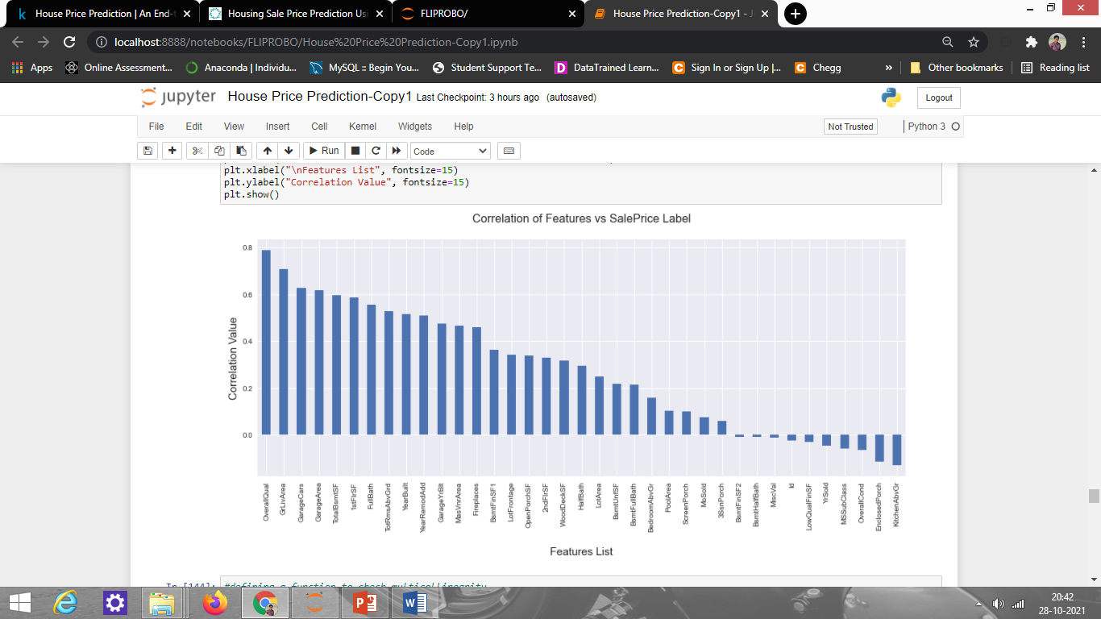

Remarks: It gives us an insight on positive and negative correlated column details.

These are some of the Graphical EDA I did to check how the features affect the target attribute. For detailed EDA, please go through my Jupyter notebook file in my GitHub.

Hardware and Software Requirements and Tools Used:

* Hardware Used:

RAM: 4 GB

CPU: AMD A8 Quad Core 2.2 Ghz

* Software Tools used:

Programming language: Python 3.0

Distribution: Anaconda Navigator

Browser-based language shell: Jupyter Notebook

* Libraries/Packages Used:
* Pandas
* Numpy
* Matplotlib
* Seaborn
* Scipy.stats
* Sklearn

**Model/s Development and Evaluation**

* Identification of possible problem-solving approaches (methods):

Both statistical and analytical approaches have been used to solve the problem which mainly includes the pre-processing of the data and EDA to check the correlation of independent and dependent features. Also, before building the model, I made sure that the input data is cleaned and scaled before it was fed into the machine learning models.

For this project, we need to predict the target attribute “SalePrice” o which is continuous output so this is a Regression problem. We have used various Regression algorithms and tested them for the prediction.

By doing various evaluations I have selected RandomForest Regressor as the best suitable algorithm for our final model as it is giving a good r2-score and good performance metrics. Other regression algorithms are also showing good accuracy but some are over-fitting and some are under-fitting the results which may be because of fewer amounts of data.

The Learning curve for RandomForestRegressor-

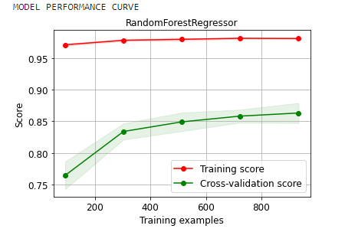

To get good performance as well as accuracy and to check my model from over-fitting and under-fitting I have made use of the K-Fold cross-validation and then hyperparameter tuned the final model.

Once I was able to get my desired final model I ensured to save that model before I loaded the testing data to analyze it and finally obtain the predicted sale price values.

* Testing of Identified Approaches (Algorithms):

The algorithms used are as follows:

* ExtraTreesRegressor
* RandomForestRegressor
* DecisionTreeRegressor
* LinearRegression
* Lasso
* SupportVectorRegressor
* Run and Evaluate selected models:

A total of 6 algorithms has been used on the dataset for training testing purpose. To perform training and testing operation(s) following functions has been defined for which codes are as follows:

# Splitting data for model building using train test split:

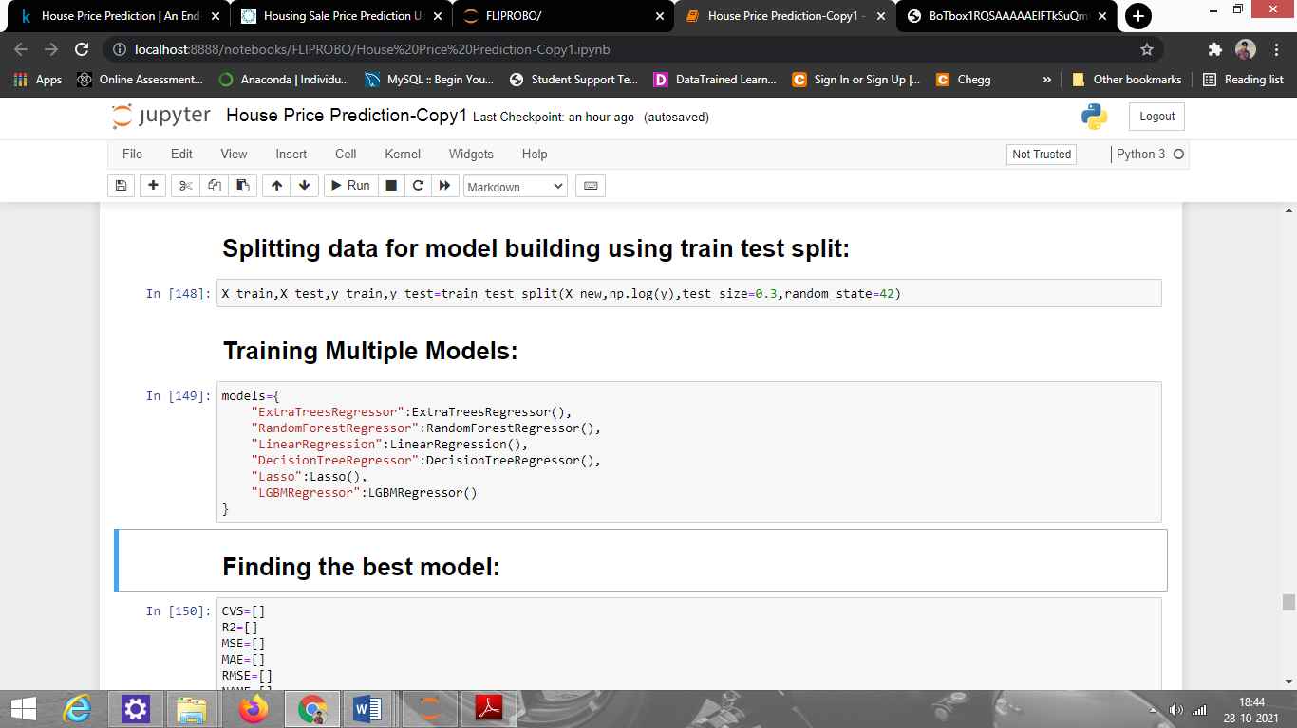

# Training Multiple Models:

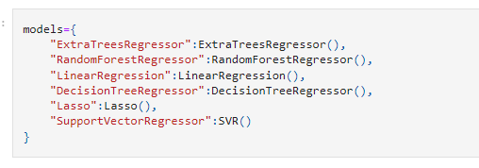

**Finding the best model:**

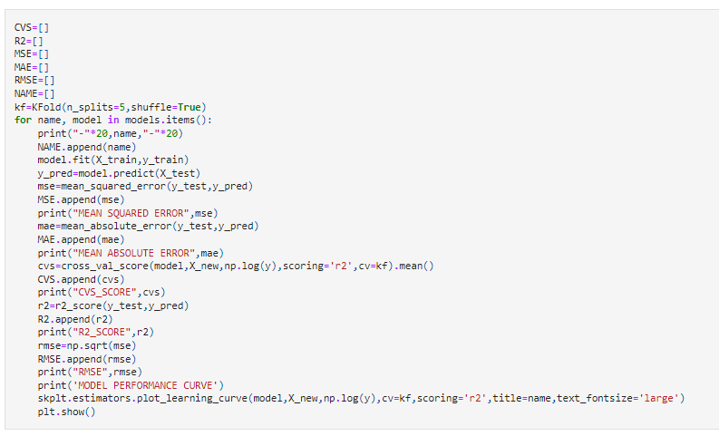

**Evaluation metrics of the models**:

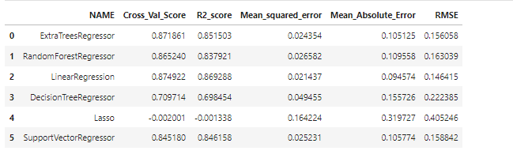

**Learning Curve of all Models:**

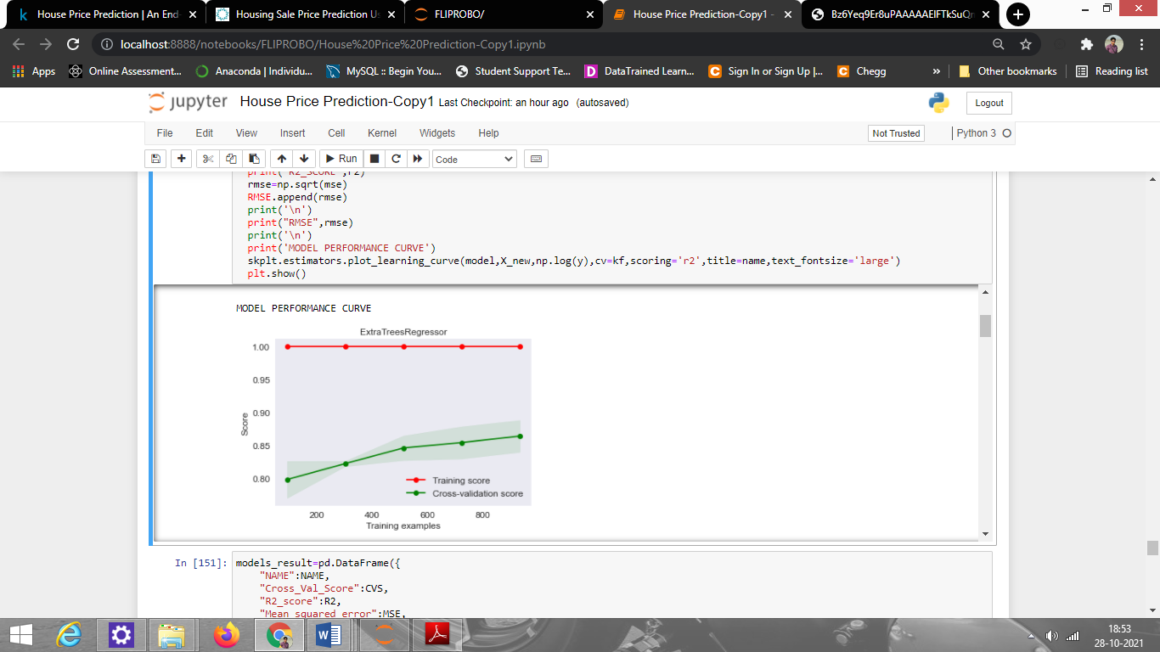

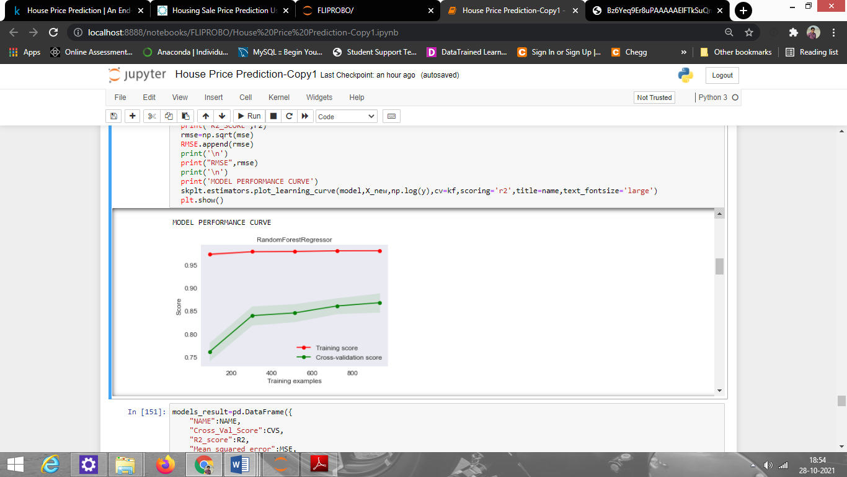

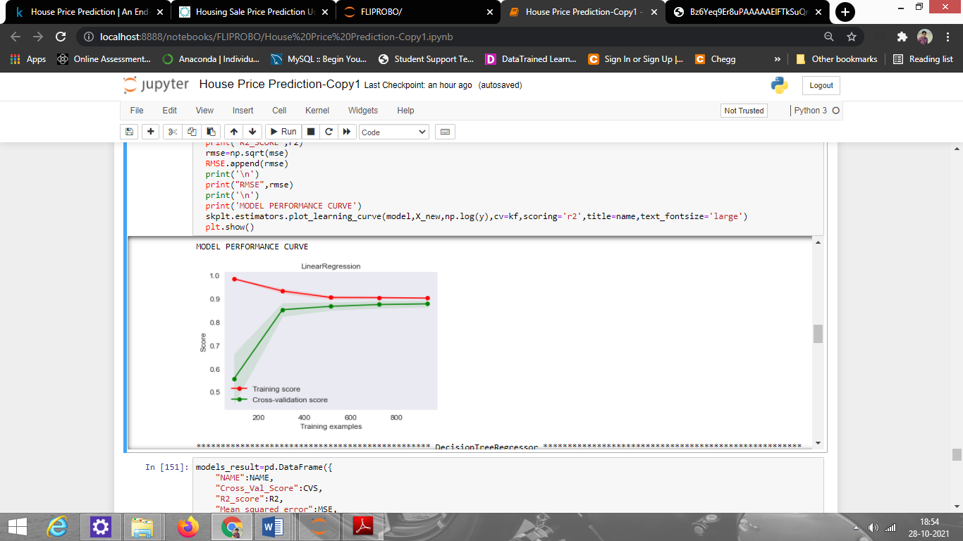

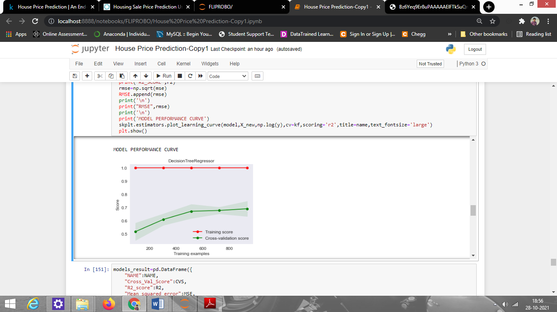

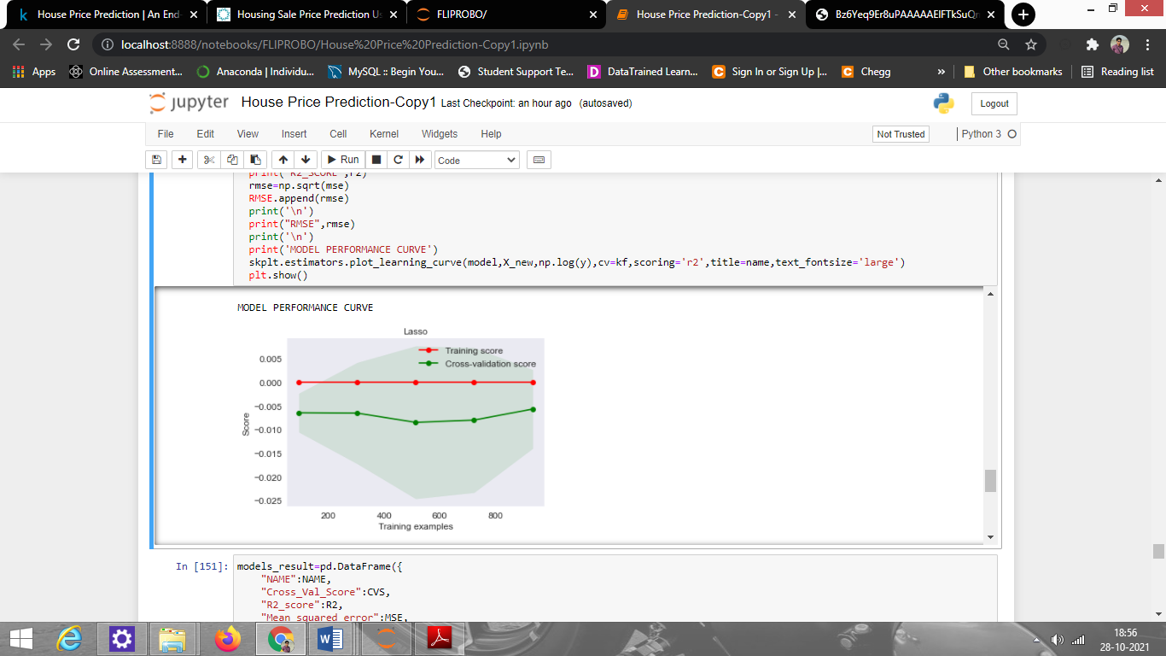

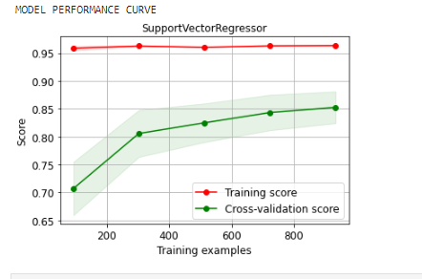

Remarks: LinearRegression model is showing a good result but when we see its Learning curve we observe that it is underfitting so We are going to proceed with RandomForestRegressor as our best model because it is performing well and also have a good Learning curve.

Key Metrics for success in solving problem under consideration:

To find out the best performing model following metrics are used:

1. R2 Score: It is used to check the model performance score between 0.0 to 1.0
2. Mean Squared Error: The mean squared error of a model concerning a test set is the mean of the squared prediction errors over all instances in the test set.
3. Root Mean Squared Error: It is the root of mean squared error.
4. Mean Absolute Error: It is the average of absolute errors for a group of predictions and observations as a measurement of the magnitude of errors for the entire group.

**Hyperparameter Tuning of the best model :**

Listing down the chosen parameters above after selecting LGBMRegressor as our best model:

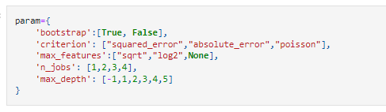

Using the Grid Search CV method for hyperparameter tuning of the best model:

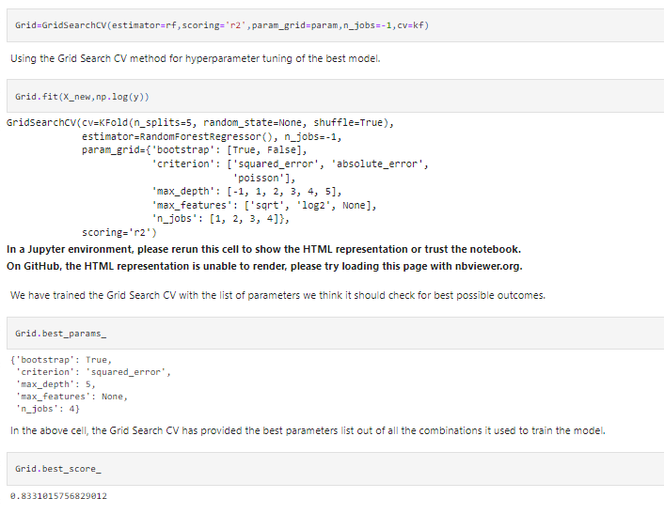

# After successfully incorporating the HyperParameter Tuning on the final Model, we have received the accuracy score of 83.31%.

Final Model Learning Curve:

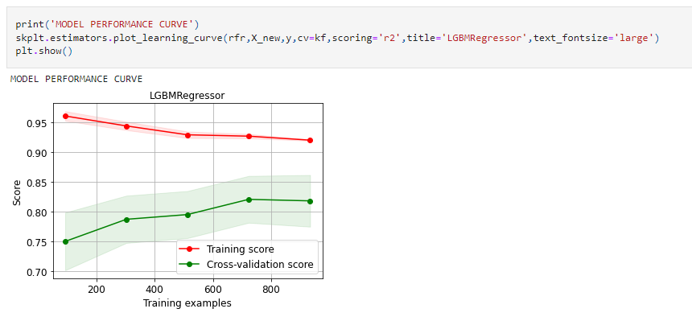

Final Model metrics:

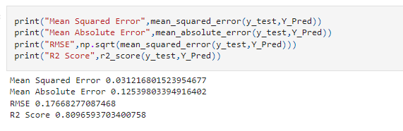

* Interpretation of the Results:

Visualizations: It helped to understand the correlation between independent and dependent features. Also, helped with feature importance and checking for multicollinearity issues. Detected outliers/skewness with the help of boxplot and distribution plot. I got to know the count of a particular category for each feature by using a count plot and most importantly with predicted target value distribution.

Pre-processing: Basically, before building the model the dataset should be cleaned and scaled. As we have mentioned above in the pre-processing steps where all the important features are present in the dataset and ready for model building.

Model Creation: After performing the train test split, we have x_train, x_test, y_train & y_test, which are required to build Machine learning models. I have built multiple regression models to get the best R2 score, MSE, RMSE & MAE out of all the models.

**CONCLUSION**

* Key Findings and Conclusions of the Study:
* The RandomForestRegressor model is working with a well R2 score of 80.96.
* The cross_val_score of the model is 86.52 which again shows that the cross_val_score is better as compared to other models in the table.
* All these points prove that the RandomForestRegressor model is working best and can be considered as the finalized model.
* Learning Outcomes of the Study in respect of Data Science

**1. Price Prediction modeling *–*** This allows predicting the prices of houses & how they are varying in nature considering the different factors affecting the prices in real-time scenarios.

**2. Prediction of Sale Price** – This helps to predict the future revenues based on inputs from the past and different types of factors related to real estate & property-related cases. This is best done using predictive data analytics to calculate the future values of houses. This helps in segregating houses, identifying the ones with high future value, and investing more resources in them.

1. **Deployment of ML models** – The Machine learning models can also predict the houses depending upon the needs of the buyers and recommend them, so customers can make final decisions as per the needs.

* Limitations of this work and Scope for Future Work

Current model is limited to housing prediction data but this can further be improved for other sectors of property price prediction by training the model accordingly. The overall score can also be improved further by training the model with more specific data.